Lab 10: Configure SQL Server Accelerated Database Recovery (ADR)

- Install MSSQL extensions in the VS code of the lab VM.
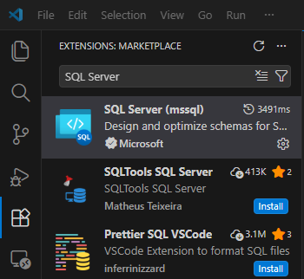
- Once the MSSQL extension is installed, configure the SQL server connect option in VS code with your local Lab SQL server credentials.
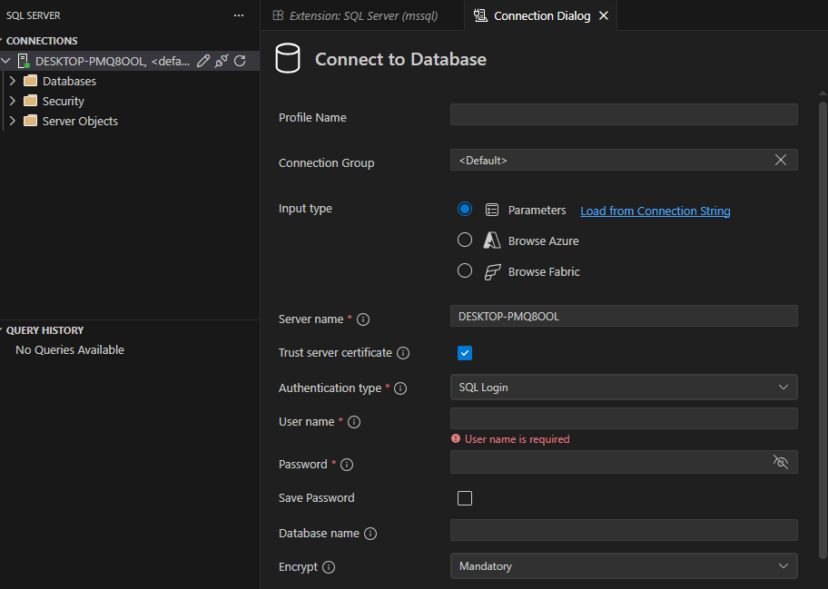

- Once your SQL server is connected through VS code, first execute the following SQL notebook.
Accelerated Database recovery – Speed up recovery.
- adr_recovery.ipynb.

